Add / Edit Limits

Overview
The ‘Add Limit’ / ‘Edit Limit’ functionality of search data module should allow user to specify rules / constraints on the attributes of selected metadata entity (category) like edu.wustl.fe.Gene or Gene Annotation. The application should provide user interface which allows user a way to see all the attributes of selected entity, specify rule for specific set attribute. This user interface needs to be generic which should display attributes of different data types, along with the condition list specific to the attribute data-types. Depending upon the data-type of the attribute, values that can be taken as a input for it varies. For example attribute of type date should only accept date values or the attribute having value domain should only accept values within the value domain range.

In order to accommodate all the above requirements of user interface, we have decided to go for the dynamic UI generation approach. The section below describes the design details of dynamic UI generation for Add / Edit limit functionality.

Dynamic UI Generation Design

The user interface for ‘Add / Limit’ page should be dynamically generated depending upon the data-type of the attribute. For example, attributes of type date should have date selection control that will allow one to select specific date or attributes having value domain should show list of values that attribute can accept and user should be able to specify values for same. Also the operators/conditions applicable to the attribute vary according the data type. For example attributes of type Boolean can have only two attributes ‘equals’ and ‘not equals’ while attributes of type string can have operators/conditions like ‘equals’, ‘not equals’, ‘starts with’, ‘contains’, ‘in’, ‘not in’, ‘ends with’. Thus the condition list associated with every data type and the UI component that displays these details are the configurable parameters. These configuration details should be stored into the xml file (dynamicUI.xml) which will have following structure:

<data-type-control>
<enumerated>
<string>
<conditions>
<in>
<displayname>In</displayname>
</in>
<notin>
<displayname>Not In</displayname>
</notin>
</conditions>
<components>edu.wustl.cab2b.client.ui.main.EnumTypePanel</components>
</string>
<number>
......
</number>
<boolean>
<conditions>
<equals>
<displayname>Equals</displayname>
</equals>
<notequals>
<displayname>Not Equals</displayname>
</notequals>
</conditions>
<components>edu.wustl.cab2b.client.ui.main.EnumTypePanel</components>
</boolean>
</enumerated>
<non-enumerated>
<date>
<conditions>
<equals>
<displayname>Equals</displayname>
</equals>
<notequals>
<displayname>Not Equals</displayname>
</notequals>
<between>
<displayname>Between</displayname>
</between>
<lessthan>
<displayname>Less than</displayname>
</lessthan>
<lessthanorequalto>
<displayname>Less than or Equal to</displayname>
</lessthanorequalto>
<greaterthan>
<displayname>Greater than</displayname>
</greaterthan>
<greaterthanorequalto>
<displayname>Greater than or Equal to</displayname>
</greaterthanorequalto>
<isnull>
<displayname>Is Null</displayname>
</isnull>
<isnotnull>
<displayname>Is Not Null</displayname>
</isnotnull>
</conditions>
<components>edu.wustl.cab2b.client.ui.main.DateTypePanel</components>
</date>
<boolean>
......
</boolean>
</non-enumerated>
</data-type-control>

At broader level, attributes are of two types:
- enumerated
- non-enumerated
Non-enumerated attributes can further be sub-divided as String, Number, Boolean, Date.
Also enumerated attributes can be of type String, Number, Boolean.

The UI component representing control for any attribute should show
- Attribute name
- condition selection drop-down box
- Control to specify values for selected condition. This portion of the component is variable and changed according to the actual data type of the attribute

Similarly UI component should provide API to get selected condition, corresponding values and the attribute entity it represents. Thus one needs to have a common interface containing these APIs which every data type specific UI component should implement.

The UML diagram below shows the different classes involved in dynamic UI generation and interactions amongst them.

UML Diagram

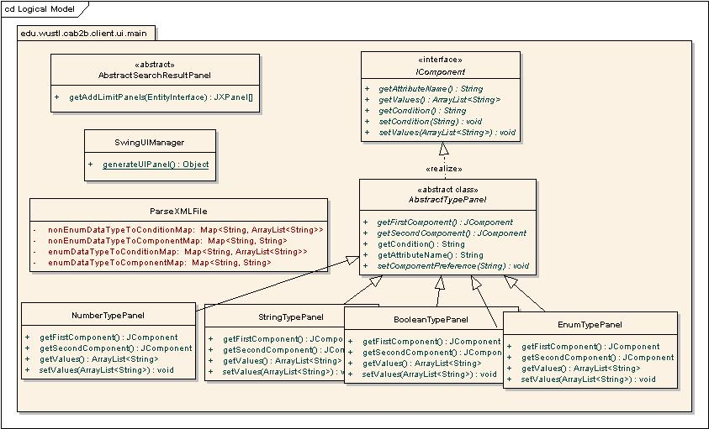

Classes and interaction Details:
- IComponent: The interface class containing method to get/set UI component details for every attribute type. The UI component classes implement this interface
- AbstarctTypePanel: This is an abstract UI component class which contains common functionalities needed by all the attribute type UI components. This class implements IComponent interface. This component contains APIs to set UI for condition list, user friendly attribute names. This class contains getFirstComponent and getSecondComponent abstract methods that every extending class should implement in order to provide the JComponent object specific to the specific data type.
- NumberTypePanel: The UI component class for Number data type. This control handles different formats of numbers like Integer, Long, double.
- StringTypePanel: The UI component class for String data type.
- BooleanTypePanel: The UI component class for boolean data type.
- DateTypePanel: The UI component class for date data type.
- EnumTypePanel: The UI component class for Enumerated data type.

All NumberTypePanel, StringTypePanel, BooleanTypePanel, DateTypePanel and EnumTypePanel classes extend from the abstract class AbstractTypePanel. Similarly each attriute type UI component should implement the getValues and setValues methods defined in the IComponent interface. They should set and return the user values to the fields displayed.

The sequence diagram to explain the sequence of steps taken to dynamically generate the UI is shown below.

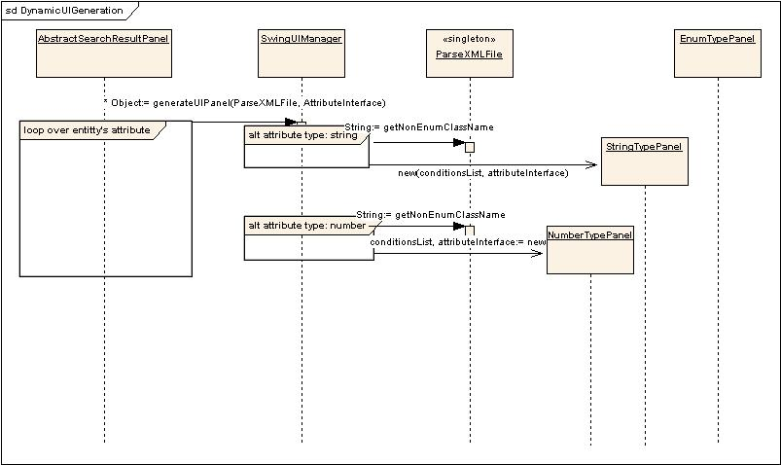

The class AbstractSearchResultPanel needs to generate the dynamic UI for a entity in selection, so it iterates over the attributes collection of the entity and passes attribute and the ParseXMLFile instance to the SwingUIManager’s generateUIPanel method, which returns the appropriate type panel (Attribute UI component) for the given attribute.

SwingUIManager class has a static utility method called generateUIPanel() , which generates the appropriate UI component corresponding to a given attribute. It uses the java reflection API to instantiate appropriate component specified in dynamicUI.xml file.

ParseXMLFile class has data structure, which gets constructed when the dynamicUI.xml file is parsed for the first time. This data structure is used later to get the list of operators given the attribute’s data type and corresponding UI component’s fully qualified class name.

